**June 6, 2022 is the FINAL DEADLINE** to email completed application and documentation to participate in the August 6th CGM Ceremony. Email application and documentation to our Regional Director Representative Luisa Antonio, [cgm@sfbec.org](mailto:cgm@sfbec.org). To help with the follow-up of your application, include Nickie Tuthill-Delute’s email address, fanhscgm.info@gmail.com. Nickie’s phone number is (661)725-8133 if you have any questions.

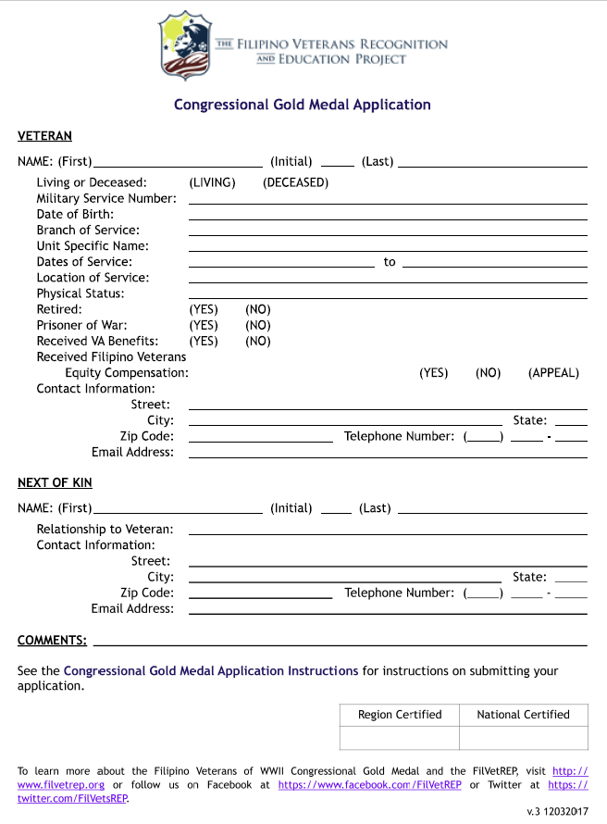

*To learn more about the Filipino Veterans of WWII Congressional Gold Medal and the FilVetREP, visit* <http://www.filvetrep.org> *or follow us on Facebook at* <https://www.facebook.com/FilVetREP> *or Twitter at* <https://twitter.com/FilVetsREP>*.*